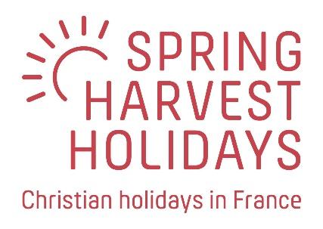

Celebrating twenty years of Le Pas Opton
We are always looking for an excuse for a party. Twenty years of LPO feels like a good reason – especially as we celebrate emerging from two very difficult pandemic seasons. So in 2023 we’re inviting everyone who knows and loves LPO to join the party - every week of the season.
Celebration weekend 30 June – 3 July
On this weekend in particular we are planning some extra-special events and gathering as many old friends as we can. Staff, speakers, worship leaders, directors, couriers and of course guests from the past are invited to join this special get-together. The weekend will include:
- Friday arrival day, evening worship and party in the bar
- Saturday celebration day with time to meet up and chill out. Join the morning Bible study if you wish and definitely the early evening celebration. Then enjoy a magnificent French banquet in the evening if you wish*. We hope to have a short presentation about the history and highlights of our twenty years at LPO
- Sunday thanksgiving day with morning worship gathering, the traditional Street Party and an evening worship concert featuring special guests
- Monday relax and return day for those not staying for a longer break.
Transport will be available to and from Nantes airport so you can travel with Easyjet from Gatwick or Ryanair from Manchester, Edinburgh or Stansted. You can also come by ferry of course.
*The Saturday evening banquet will be an optional ticketed, paid-for event.
Very special offers
As an honoured and valued friend of LPO, our offer to you is:
Join us all weekend, staying in a mobile home for just £199. Book your own flights or we’ll sort out a ferry at a competitive price. Hire items and other extras will be charged in the normal way. If you want to stay more than three nights then pay these daily add-on prices: BYO £50, Tent £60, Firgrove or Ashglade £85, Pinewood or Evergreen £120.
How to book
These special prices are not available through our online booking system so please email your booking request to info@springharvestholidays.com with your dates, travel plans and any extras required. Please quote “the £199 offer”. Matt or Kirsty will get back to you with a confirmed booking and then take your deposit.

